APPENDICES

Contents

Dispenser Test 4

Launching Limiter Tuning 6

APPENDIX A: Images

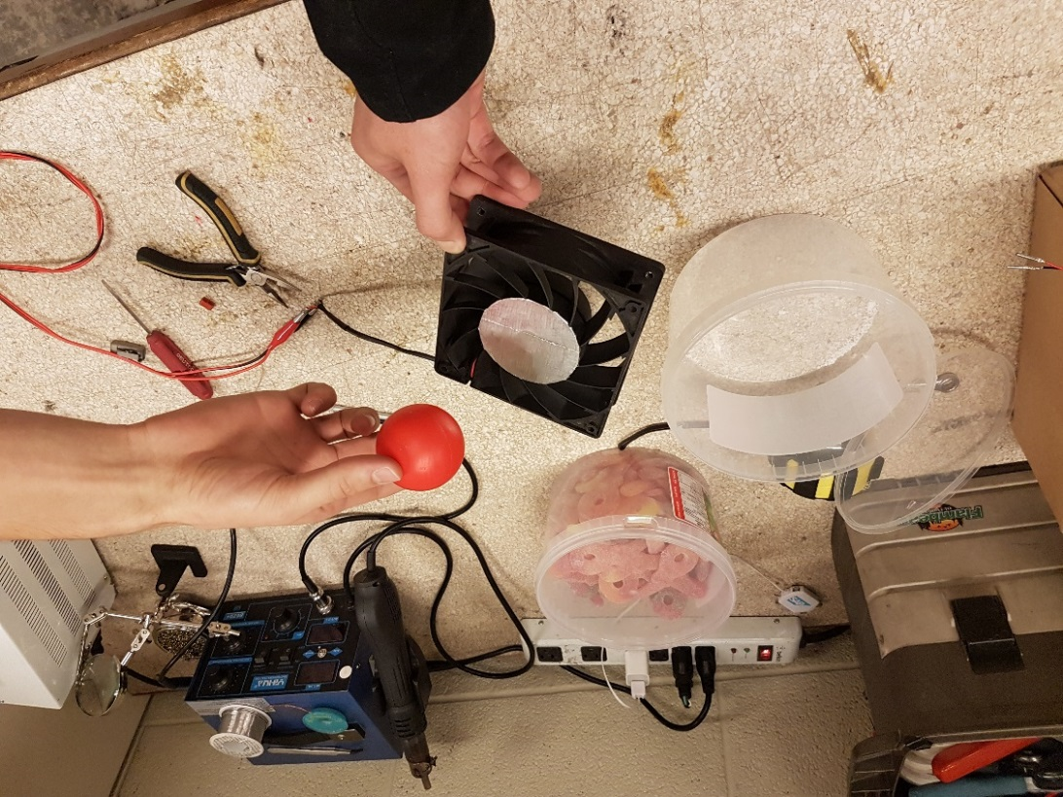

Figure 1 (Test 4): The bucket, the CPU fan, and the ball. Even with different angles, the ball went directly into the bucket. It did not deflect when it was position above the fan.

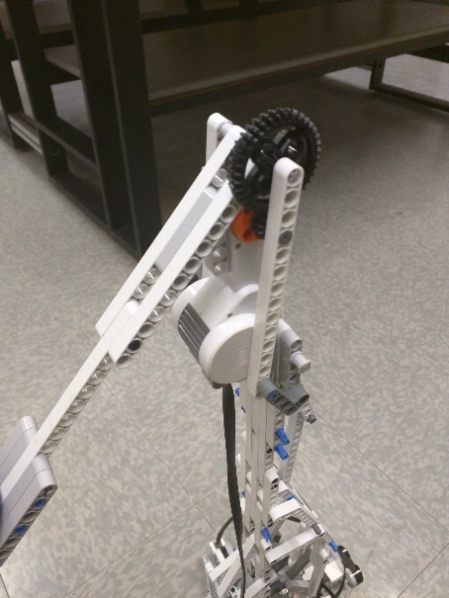Figure 2 and 3 (Tests 8 and 9): We wanted to try other more powerful catapult mechanism. The first image shows the mechanism for a catapult with gears.

We tried different setup with the gears, but too much new problems were introduced. More specifically, because of the high motor speed, the gears were continuously slipping. We concluded that the use of gears was better suited for low speed use.

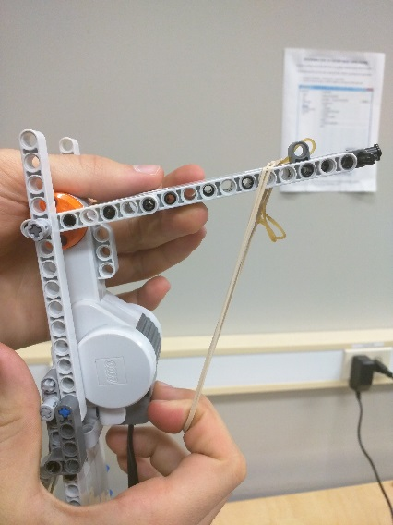Figure 3: We also tried attaching rubber bands to the catapult, but we were not able to have a successful design.

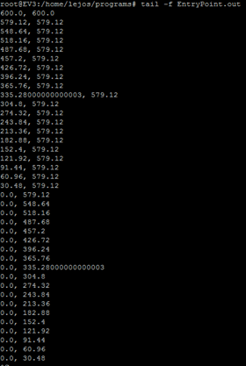

Figure 4: Results of test 23

APPENDIX B: Test results

See also Excel spreadsheets in Dropbox.

# Dispenser Test

Done by Romain Nith on the 27/03/2017

Problem: Determine the allowed robot-dispenser distance error.

Setup: Robot place next to the dispenser. Let the ball fall into the dispenser and record for each incrementation in one axis the result

The origin is set on the robot arm’s middle for the Y-axis and the edge for the X-axis (+)

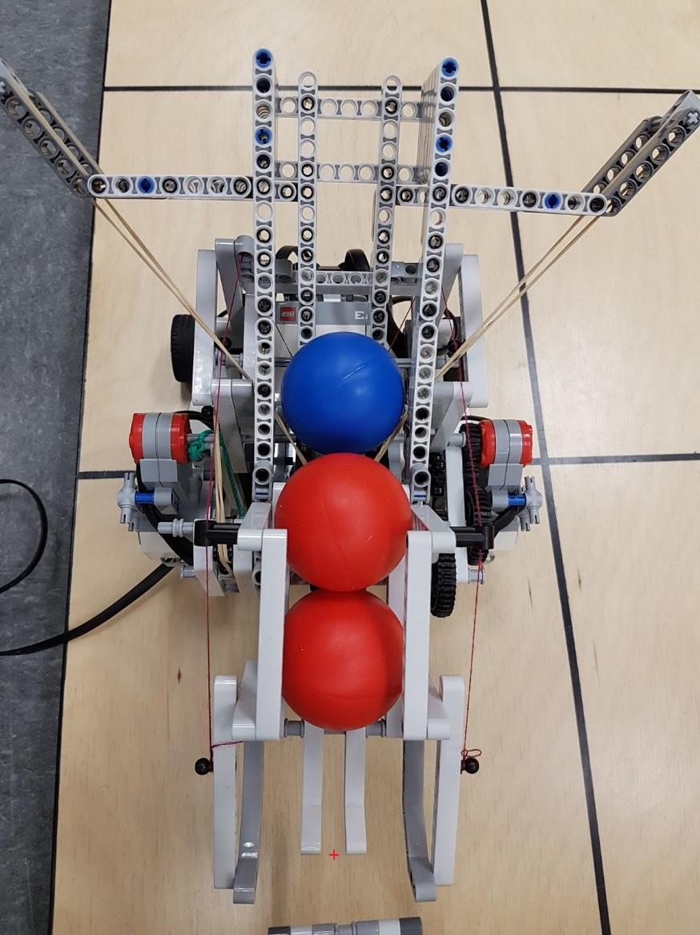

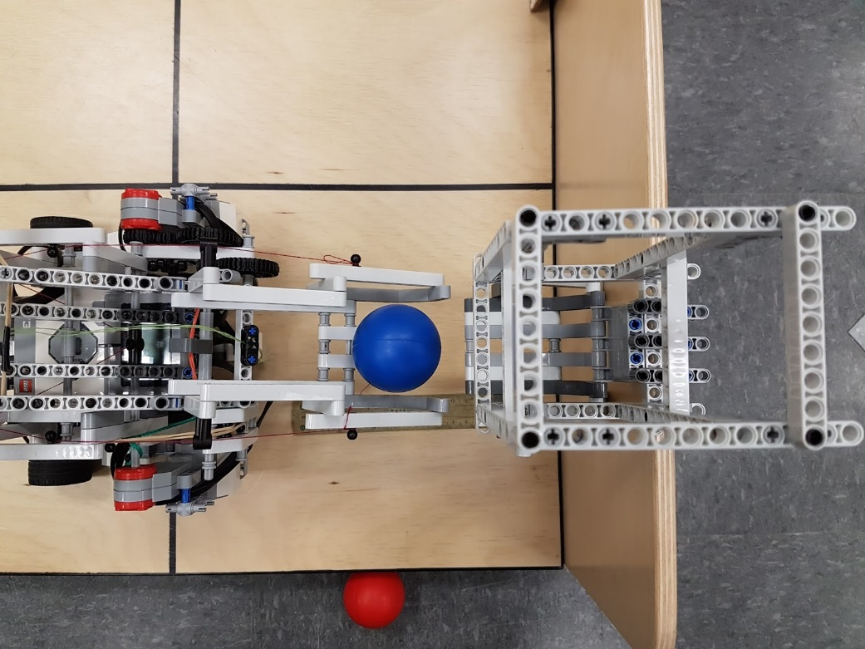

Varying x and setting y at 0 cm

|  |  |
| --- | --- |
| Distance between Robot and Dispenser (in cm) | Did the ball lend in the reservoir?* |
| 0.5 | Yes |
| 1 | Yes |
| 1.5 | Yes |
| 2 | Yes |
| 2.5 | Yes |
| 3 | No |
| 2.9 | No |
| 2.8 | Yes |

Varying y and setting x at 2.5 cm

|  |  |
| --- | --- |
| Distance between Robot and Dispenser (in cm) | Did the ball lend in the reservoir?* |
| 0.5 | Yes |
| 1 | Yes |
| 2 | Yes |
| 3 | Yes |
| 3.5 | Yes |
| 4 | No |
| 3.75 | No |
| 3.5 | No |
| 3.4 | No |
| 3.3 | Yes |

(*) Is successful when 8 or more out of 10 trials are successful

Conclusion: the V2 “Ball Reloading and Reservoir Mechanism” has an acceptable error of

[2.8; 3.3] cm.

# Launching Limiter Tuning

Done by Romain Nith on the 27/03/2017

Problem: Crossbow launches the ball too far (9 tiles without hitting the ball)

Solution: Add a stopper to reduce the elastic band travel

Procedure: Robot is positioned at 7 tiles from target. Add a Lego piece in on the crossbow’s barrel, launch and record distance. Increment the stopper until requirement is met.

|  |  |  |
| --- | --- | --- |
| Stopper position according to the exit of the launcher | Tile when it hits the floor | Hits target? |
| 0 | 9 | Yes (Direct hit) |
| 2 | 8 | No |
| 4 | 7 | No |
| 5 | 6 | Yes |
| 6 | 6 | Yes |
| 7 | 5 | No |

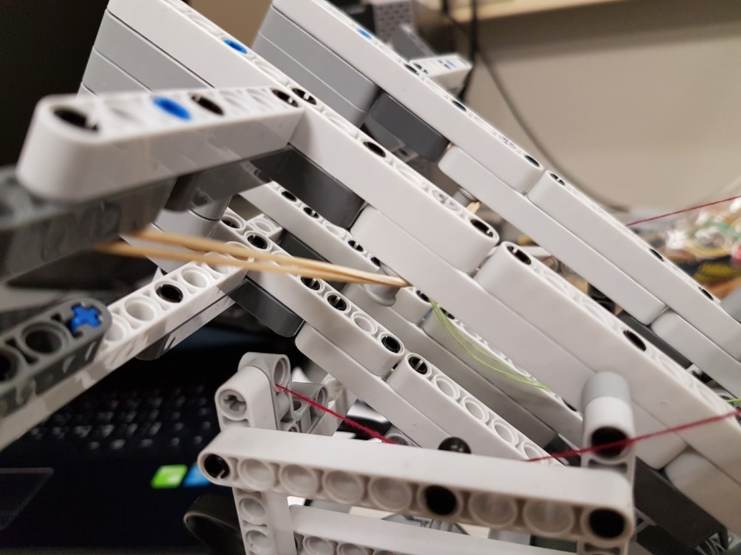

Result: At position 5 and 6, the stopper managed to launch the ball at the required distance while hitting the floor within specifications. To prevent losing too much momentum when hitting the floor, the stopper will be placed at position 5.

Remarque: To prevent damaging the stopper Lego part, we chose a small piece that has a 3 block height for stronger structure.

APPENDIX C: Software testing localization

See Word document “Software testing for localizer”